POWERHOUSE/SNAP: This group will resume in the New Year.

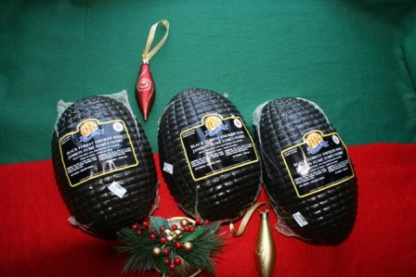
Annual Ham Sale - The Senior Band is selling Black Forest Hams again this year as a fundraiser. These are top quality, fully cooked, 2 kg boneless, selling for $20.00 each. Please see any band member, or sign your name on the sheet in foyer, to order. The deadline is December 11th. Thanks for your support.

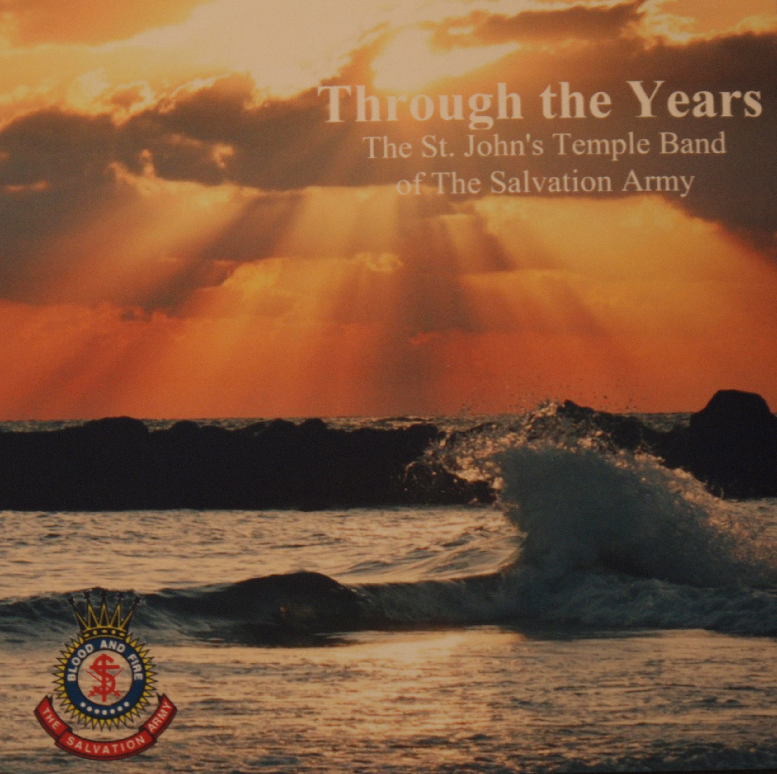
To assist the Temple Band in the fundraising for new instruments, Doug Downey has done a CD of Temple Band pieces collected from Anniversary Concerts from 1964 up to 1976. The proceeds of the sale will be given to the Temple Band. These will be great stocking stuffers for Christmas or a great addition to your collection of S.A. Band Recordings. The cost of the CD’s is $10.00. To purchase a CD you may contact any band member or the Corps Office.

CANTUS VOCUM CHAMBER CHOIR - presents Night Before Christmas on Sunday, 18 December 2016 at 4 PM at Wesley United Church, Patrick Street. Take a break from the hustle and bustle of the season to relax in the festive atmosphere of Wesley Church for an afternoon of Christmas songs and carols, Cantus Vocum style. Hear the inimitable Karl Wells bring to life Charles Dickens’ beloved “Christmas Carol” as “clutching, covetous old sinner” Ebenezer Scrooge is transformed into “as good a man as the good old city knew” through the power of Christmas. Tickets $20/15 from choir members or at the door. Further information, www.cantusvocum.com. Follow us on Twitter. Like us on Facebook.

Holy Heart High School proudly presents "Music to Warm your Heart"- A concert featuring performances by the schools instrumental and choral ensembles. Monday, Dec 5th, -7:00 PM. Holy Heart Theatre. Tickets are $10 adults. $5 student/senior or $25.00 for a family of 4 and can be purchased at the door. Come start the Holiday Season with Holy Heart!

Baby Shower - will be held for Laura Brace on Monday, December 19th in the Temple gymnasium from 7-9 pm. All ladies of the Corps are welcome. I realize this is a busy time, however Laura is only here for a few days and I know she would appreciate seeing you. If possible, gift cards or cash would be preferable as she is flying home and won't have much room for gifts. Laura is not registered anywhere and whether she has a boy or girl is yet unknown.
Temple Times

101 Torbay Road, P.O. Box 21060, St. John’s, NL A1A 5B2

Phone: 722-2467 Fax: 737-0471

Corps Officers Majors Rene and Wanda Loveless 237-7153

Corps Sergeant Major Rick Hynes 745-1745

Youth Director/

MUN Chaplain Erika White 746-3802

www.stjohnstemple.com

MISSION STATEMENT

St. John’s Temple exists solely to glorify and serve God. Our mission, founded upon Christ’s command “to go and make disciples” (Matthew 28:19-20, is to proclaim the message of salvation, seek to win the lost for Christ and nurture followers in their faith. We will strive to be a caring community as we celebrate our faith through worship services, teaching of the Word and opportunities for individual expression and commitment.

December 4th, 2016
We extend a very warm welcome to everyone.
This second Sunday of Advent will feature our Sunday School Pageant and Youth Music Sections
If you are visiting, we are so glad to have you with us today. Please fill out a welcome card and place it in the collection plate or pass it to an usher. God Bless You!

Be joyful in hope, patient in affliction, faithful in prayer” Romans 12:12
May we always pray for one another, remembering those listed and others we know that are going through difficult and challenging times in these days.

Major Lorraine Abrahamse Shirley Hallett
Aubrey Bonnell Rhoda Reid
Baby Everly (Michelle’s Niece) Major Lorne Pritchett Major Joan Stratton Jacob Anstey Shirley Bartlett Rosemary Green
Jack Crane Donna Paul Fran Chaytor Colonel Ken Tutton Major Olive Perry Major Karen Puddicombe
Please be in prayer for the Mary Brown’s Christmas Dinner on December 11th.

Let us also be in prayer for the ministry of St. John’s Temple

The Leadership -Pastoral Team

Local Officers and Program/Section Leaders

Our Children/Youth & Post-Secondary Students

That people will come to Faith in Jesus

For the Mighty Moving of the Holy Spirit among us

Women’s Ministries Christmas Dinner – Tuesday, December 6th, St. John’s Temple, 6:00 p.m. Guest is Captain Krista Andrews. Tickets are $20 and are available from Greta Orsborn. Sign-up sheet in foyer!

Prayer Shawl Ministry –– Thursday, December 8th, at Bonnie’s House.

2016 Christmas Kettles
- The Temple Corps is responsible to provide coverage for Kettle locations at Walmart, Dominion (Nov. 17-Dec. 9) Costco (Dec. 10- 24) on Stavanger Drive and the Liquor Store, Howley Estates.
- Our Volunteer Coordinators this year are Betty Cunningham, Major Eva Goulding, Major Fran Duffett, Major William Loveless and Gail Sexton.
- If you are able to give some time to help us in this way, we would be most grateful. Thank you for your support!

CAR SEATS NEEDED FOR MARY BROWN’S CHRISTMAS DINNER – We are in need of car seats for the Mary Brown’s Christmas Dinner on December 11th. Many of our older seats have passed their expiry date and have been discarded. If you have seats that are not expired and you are no longer using them, it would be appreciated if you would consider donating them to the Temple or if anyone has a car seat that we could borrow for that afternoon it would be greatly appreciated.

Grow With Me: Wednesday, December 7th, 9:30 a.m.-11:30 a.m., at the Temple. This play group is for children 6 and under.

Christmas Eve Services at the Temple - Christmas Eve Youth Service at 4:00 p.m. - Christmas Eve Candlelight Service at 6:30 p.m.

Sincere Thanks and Appreciation - The Sanctuary is beautifully decorated again this year, thank you to Arlene Riche and her team for doing such a wonderful job. It was good to have members of the Youth Group assisting again this year.

Sunshine Bags
- Thank you to those who helped pack over 800 Sunshine Bags this past week. The distribution schedule is as follows:
- Sunday, December 4th, 2:30 p.m. – Chancellor Park Chapel at 2:30 p.m. followed by distribution of Sunshine Bags with the Senior Band.
- Monday, December 4th, 6:30 p.m. – Pleasant View Towers with the Senior Band.
- Tuesday, December 6th, 6:30 p.m. – Health Sciences and the Janeway with the Senior Band.
- Thursday, December 8th, 6:30 p.m. - St. Luke’s with the Youth Band.

Please pray for all involved in this special Community Care outreach this year. If you would like to volunteer with the distribution of the Sunshine Bags please contact Major Wanda or call the office.

